Git & GitHub – 02
- Install git.
sudo yum install git -y
Use command git –version to see whether git is installed and displays version as well.

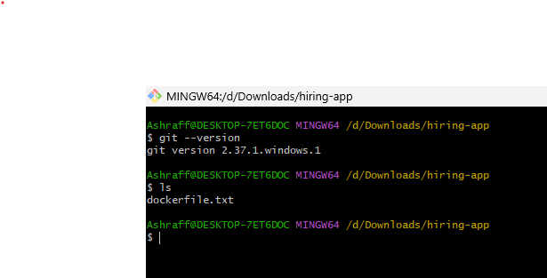

- Create a repo in github with README.md and .ignore file.

Created a repository with name, Test-01 making README & .gitignore as Java on and as public
Next in Add File created a .gitignore file

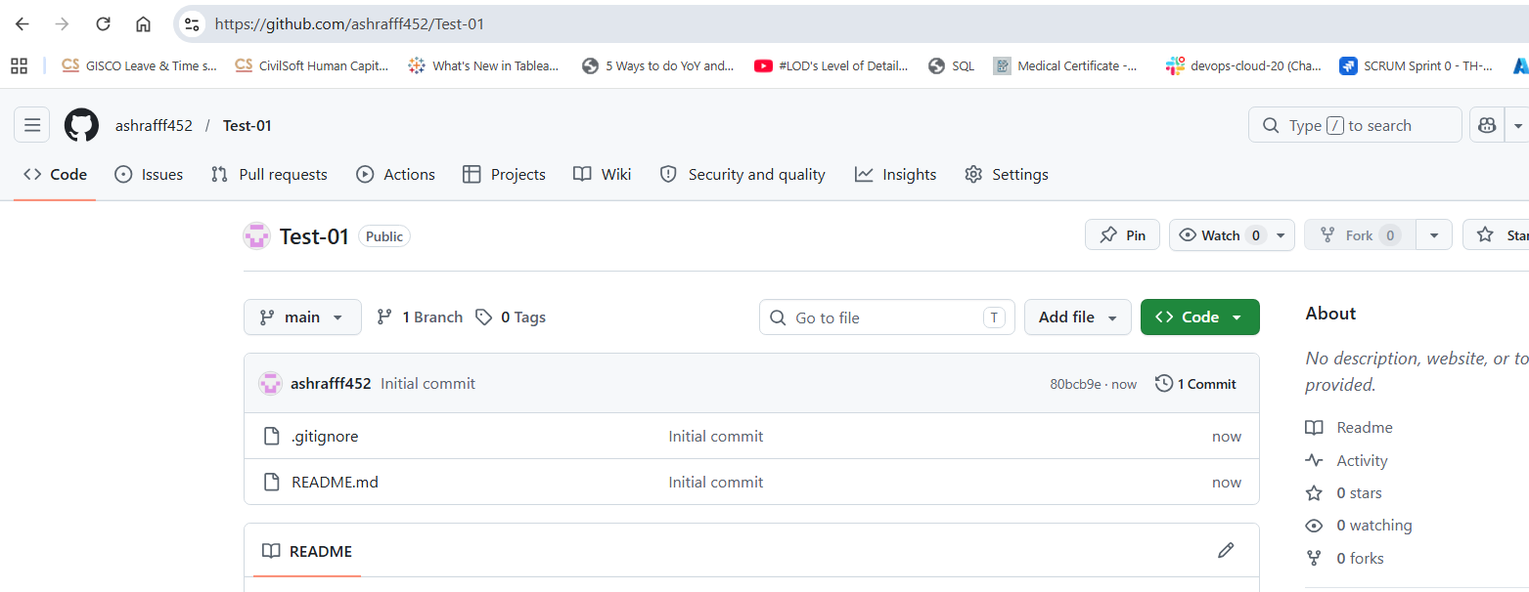

- Clone the created repo to local.

Used git clone <SSH Url> in local machine to clone from the central repository

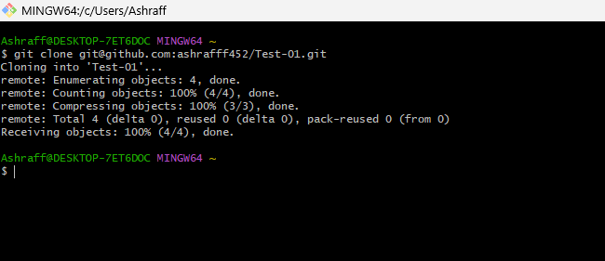

- Create two files in local repo.
Created two files, file1 & file2 in my local repo
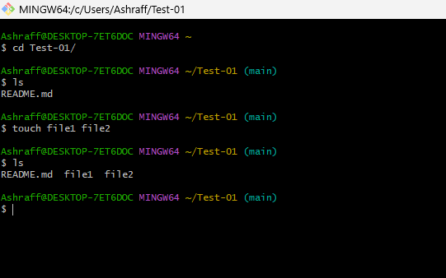

- Commit two files and push to central Repository.
After creating two files used git add . & git commit -m “added files to main”
Next git push -u origin main to push to central repository

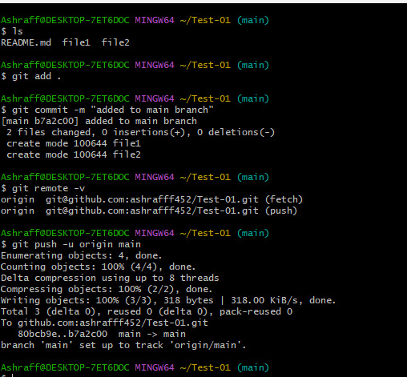

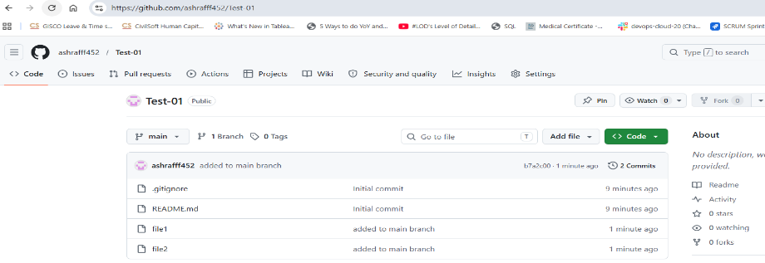

- Create a branch in local and create a sample file and push to central.
-Created a new branch by command, git branch feature
-Checkout to feature by command git checkout eature
-Created a sample.txt file
-Pushed to central repository by the command git push -u origin feature
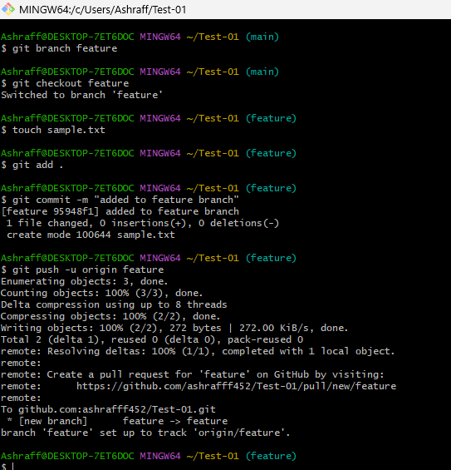

- Create a branch in github and clone that to local.
Created a branch named Dev in central repository
After git fetch the Dev branch is visible here
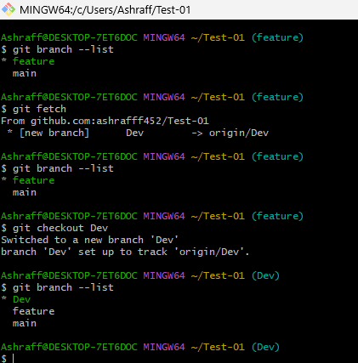

- Merge the created branch with master in git local.

By using, git checkout main the branch will changed to main
Used command git merge Dev to merge Dev with main branch.
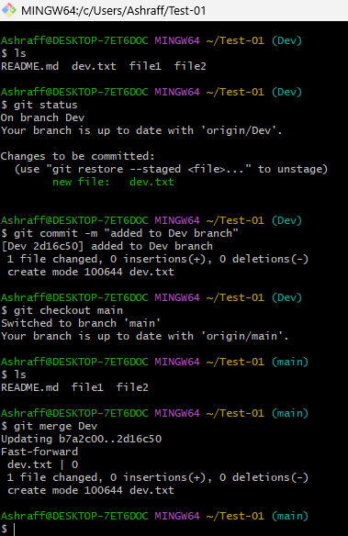

- Merge the created branch with master in github by sending a pull request.
First, make sure your local changes are pushed to GitHub:git push -u origin Dev
Created a Dev.txt file in Dev branch
Now open your repository in GitHub in your browser. We can see
“Compare & pull request” for the Develop branch. Click it.
Set:
base branch: main
compare branch: Dev
Review the changes (we see dev.txt added), then click Create pull request. After
that, click Merge pull request and confirm the merge. Once merged, main will include the changes from Develop.
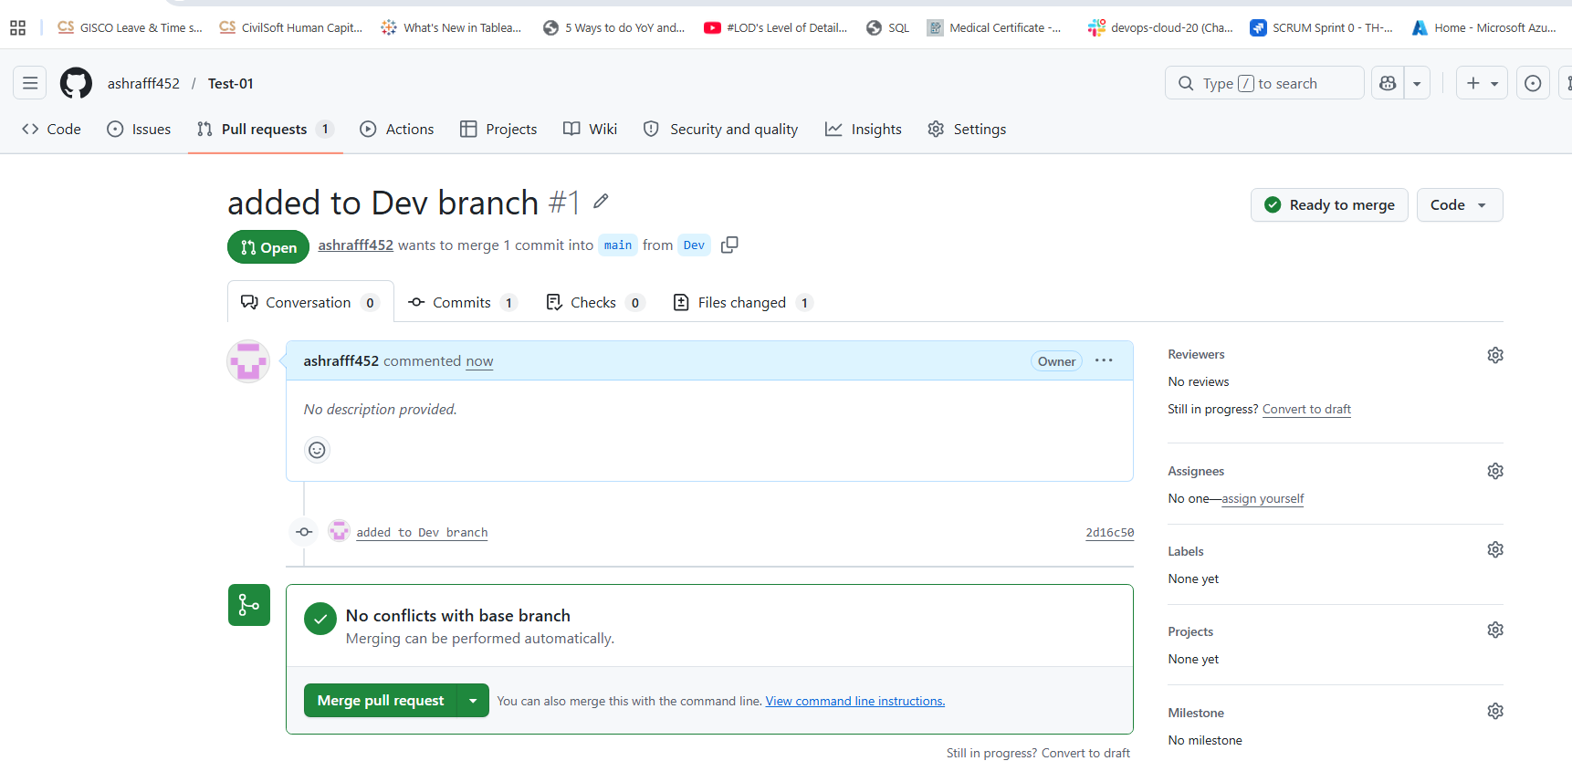

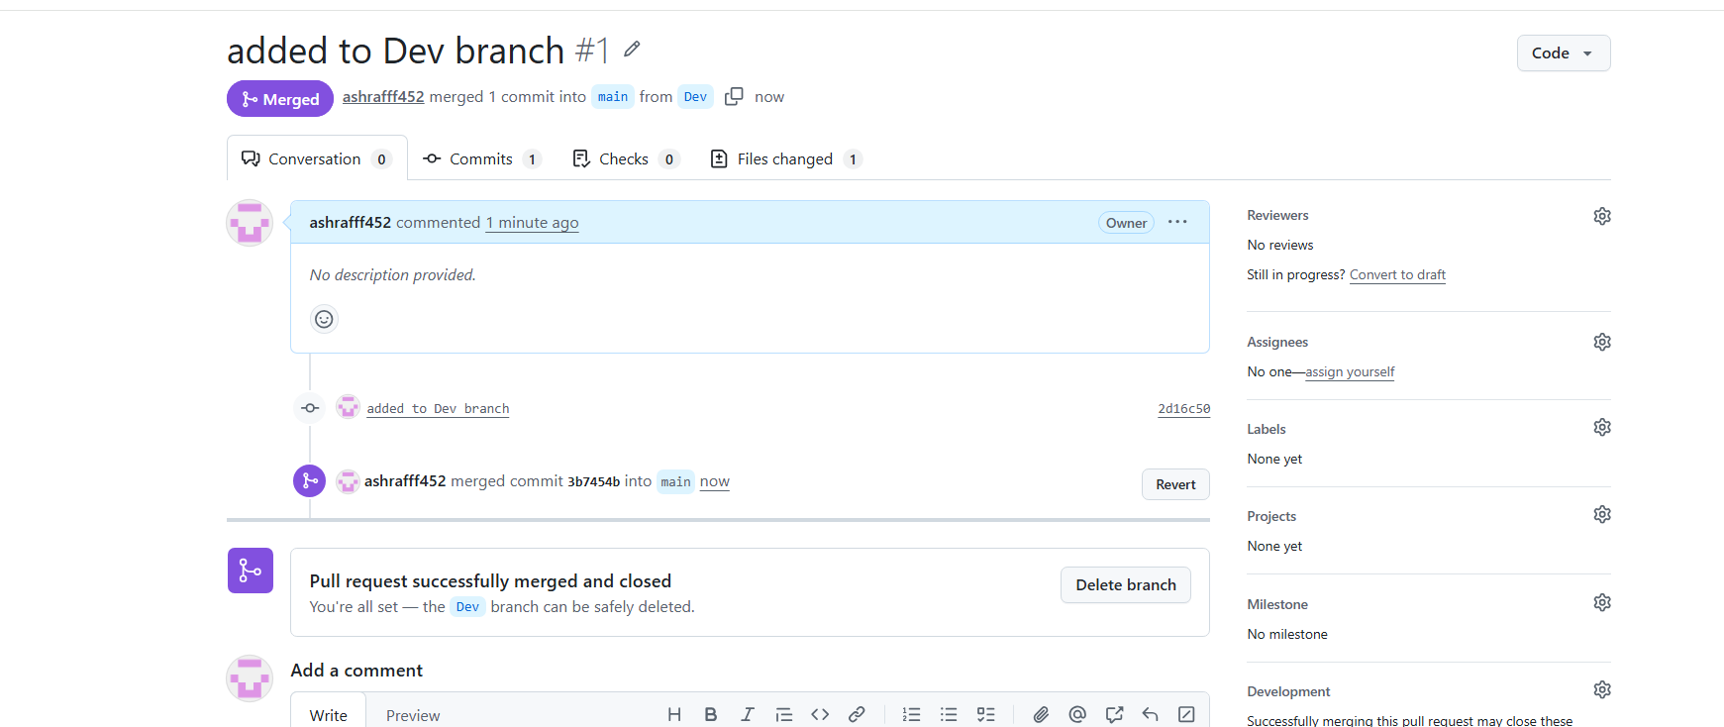

- Create a file in local and send that to branch in github.
Created a file A.txt in feature branch
git add . , git commit & later git push -u origin feature to push to central repo
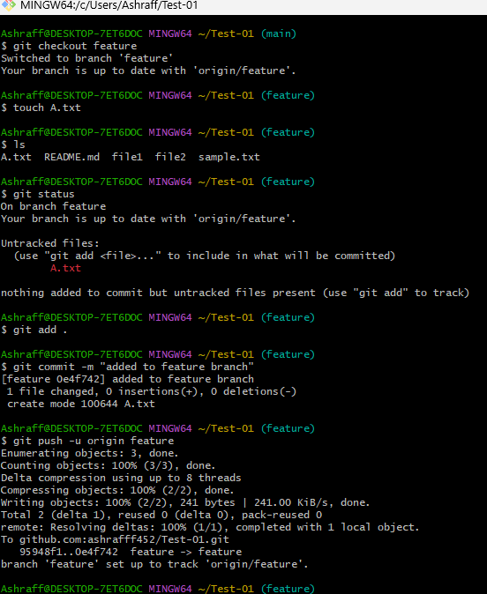

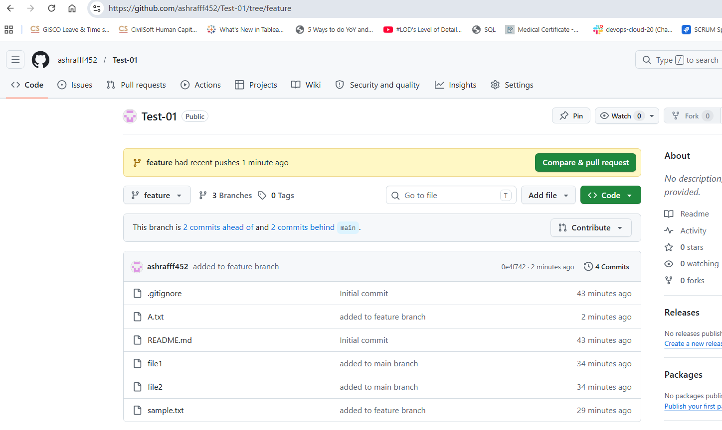
- Clone only a branch from github to local.
We use the command
git clone --branch feature --single-branch git@github.com:ashrafff452/Test-01.git

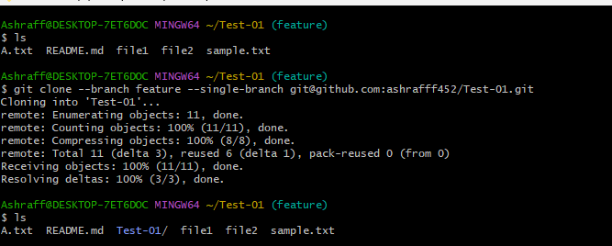
- Create a file with all passwords and make that untrackable with git.
Created a password file with credential
Next created a .gitignore file and added password file name and done the git add, commit and git push -u origin Dev & we see the .gitignore file but password file not shown
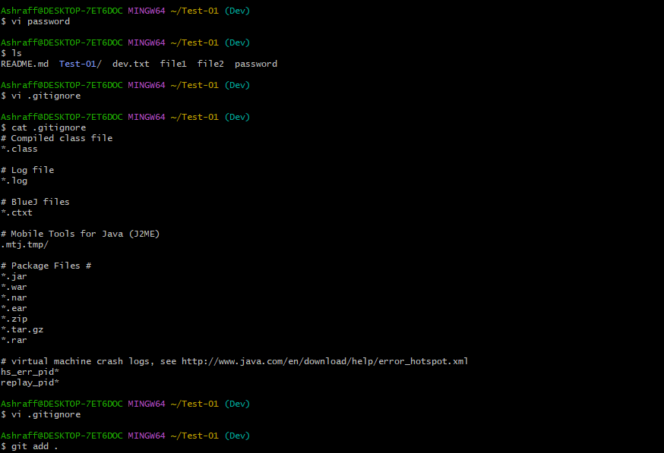
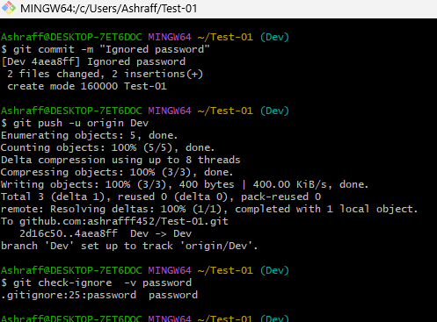

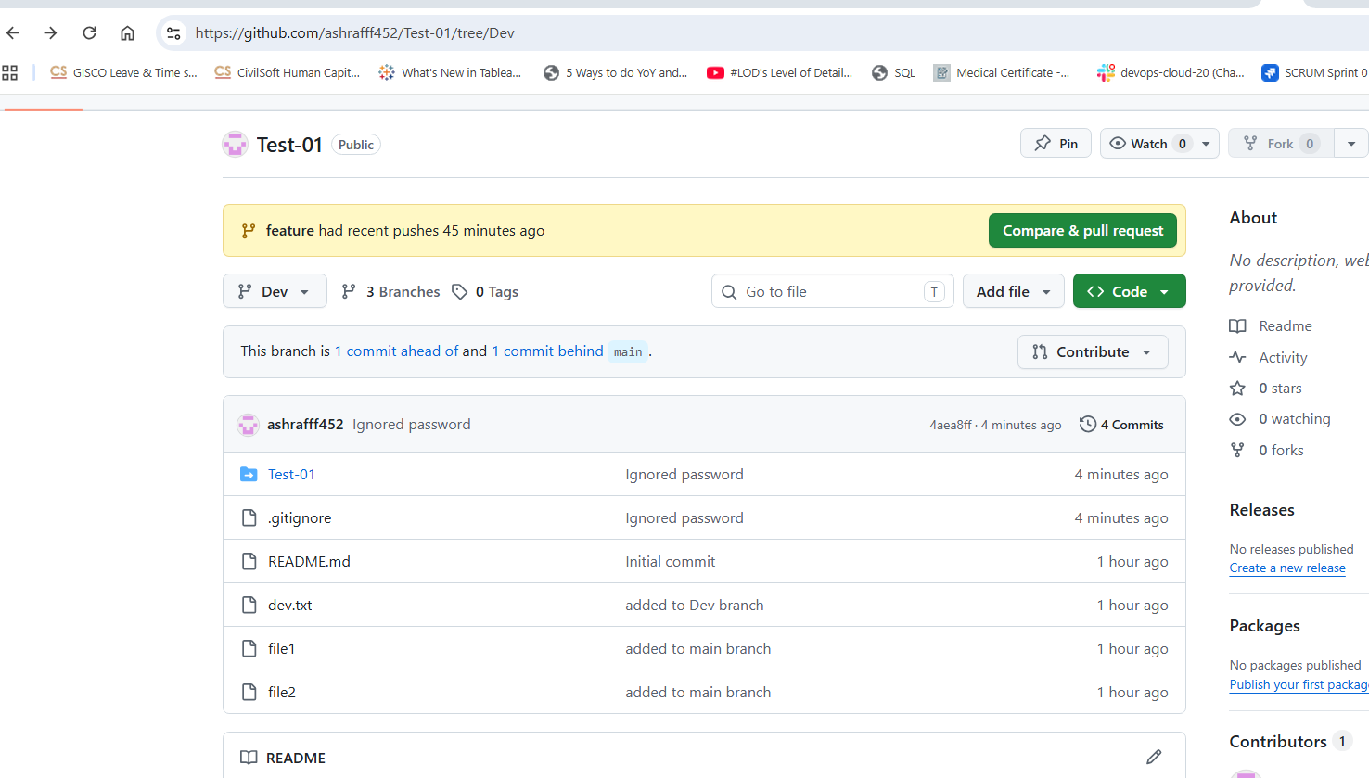

- Make a commit and make that commit reset without savings changes.
Created a Tmp_test file and done git add, git commit
To reset git reset --hard HEAD~1
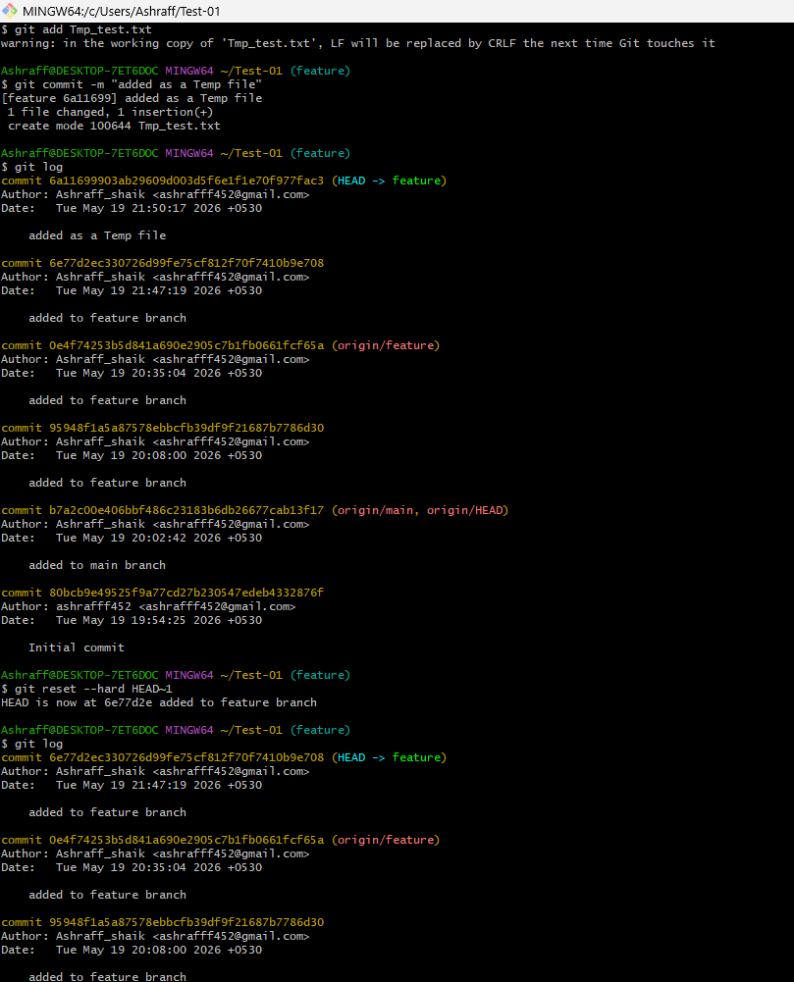

- Revert a commited commit to the older version.
Created a file bb and git add bb, git commit & then
git log –one line to see the log
git revert 4a7f619
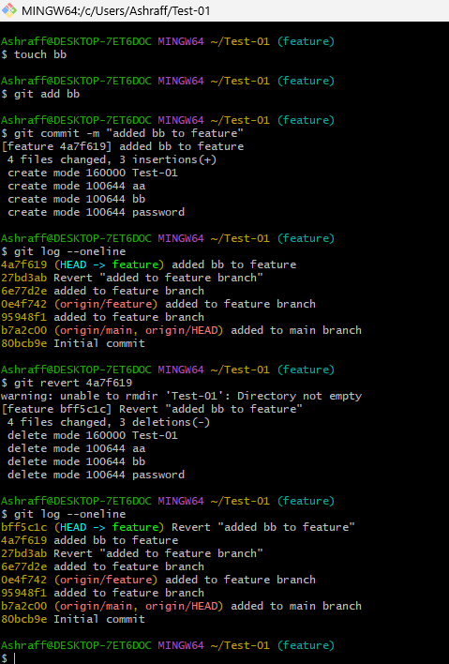

- Push a file to stash without savings the changes and work on another file.
Created a file BB
Moved to stash memory git stash -u command

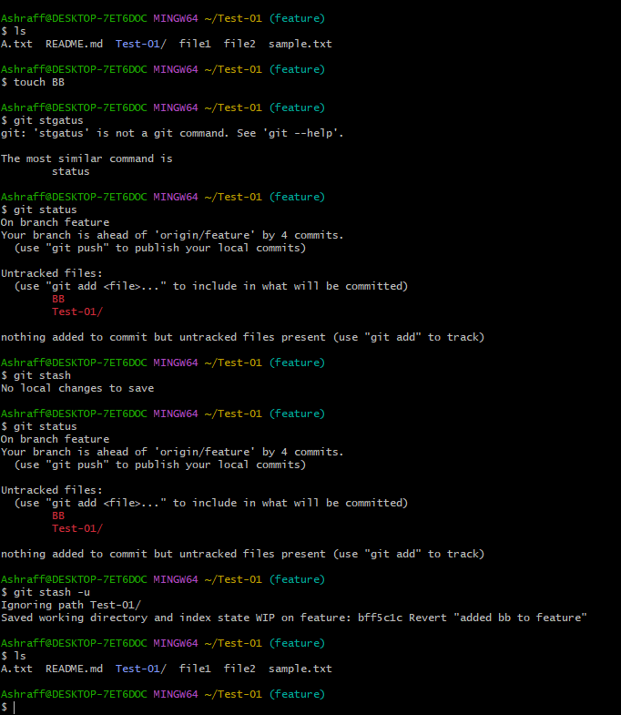

- Undo the stash file and start working on that again.
Using git stash list
git stash pop
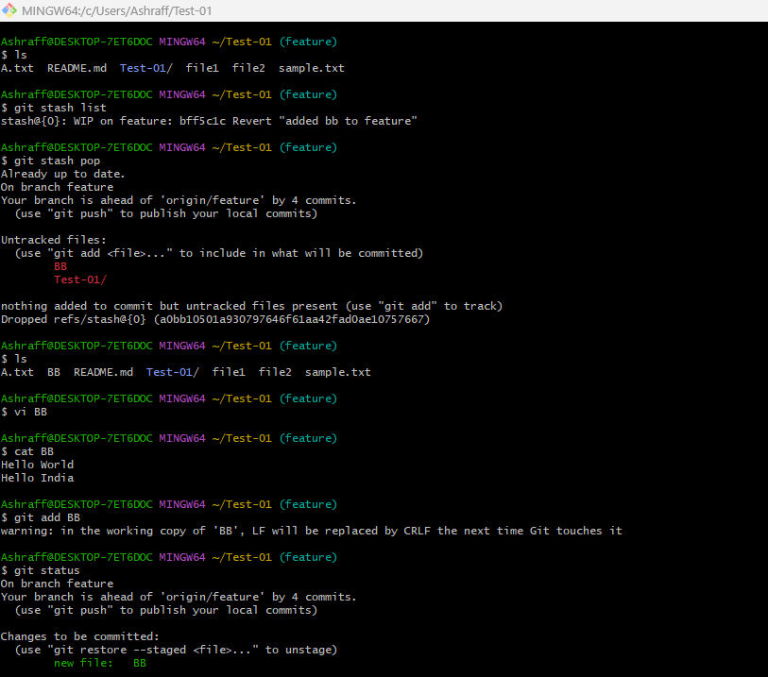

- Generate a ssh-keygen and configure into github.
SSH keys were generated in Git Bash using the ssh-keygen command. During this process, two
files were created inside the .ssh directory:
id_ed25519 Private key
id_ed25519.pub Public key
The private key remains securely stored in the local system, while the public key is used for GitHub authentication.

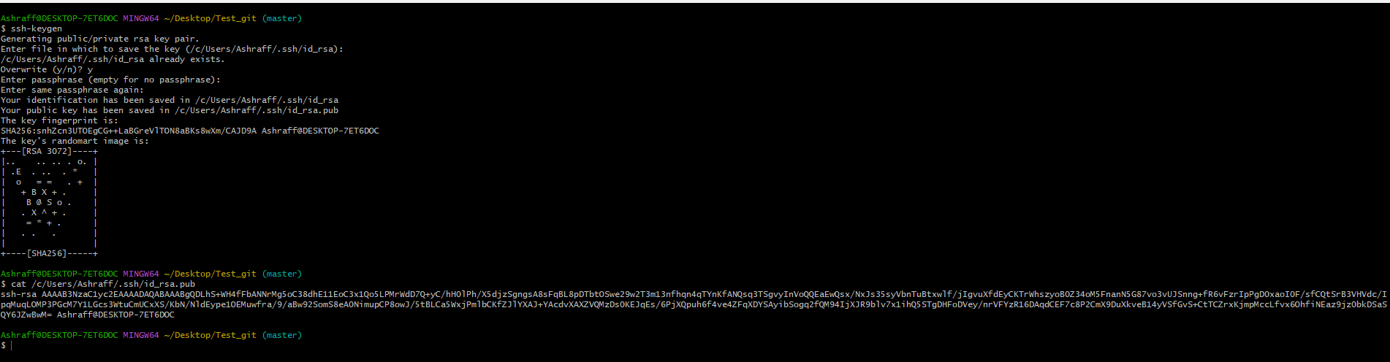

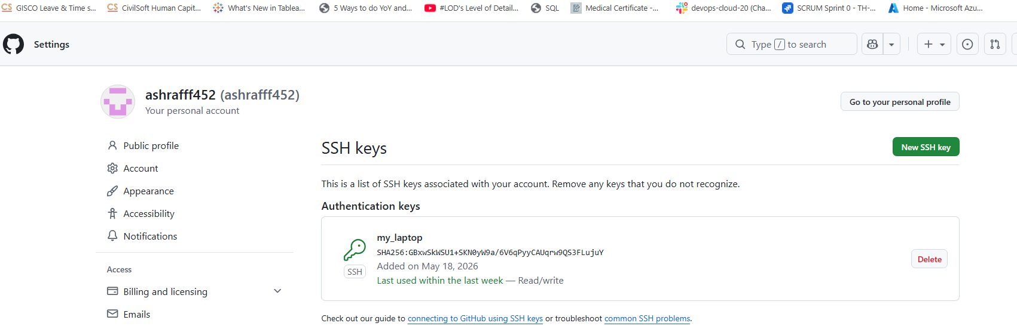

- Configure webhooks to github.
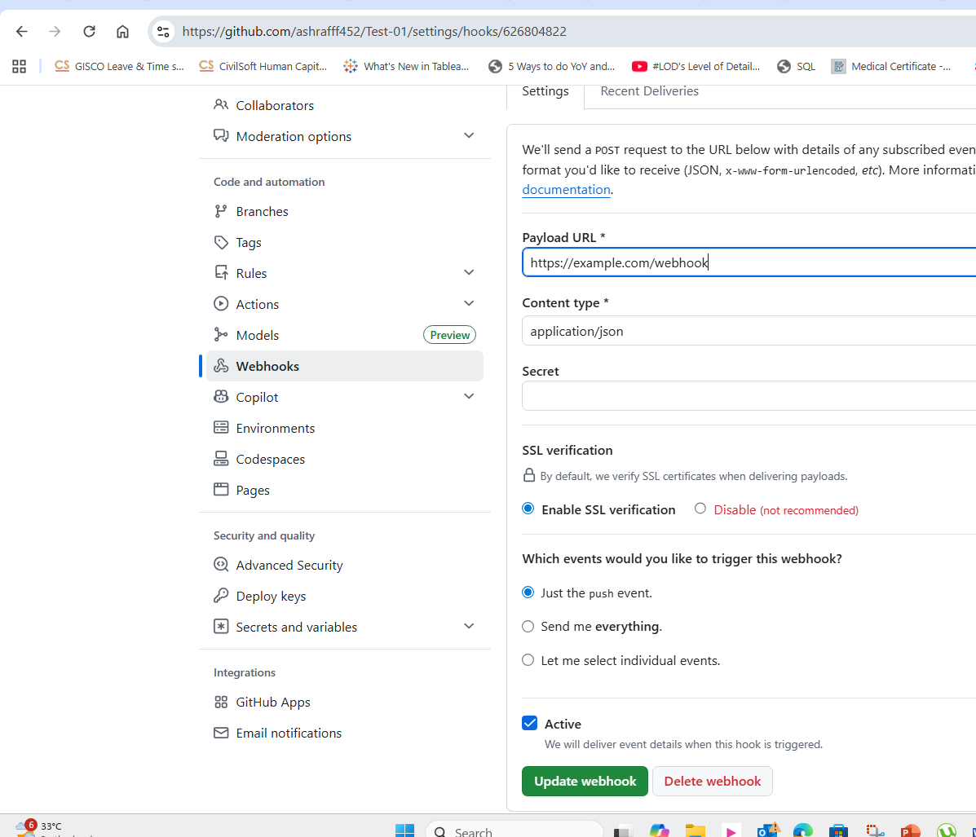

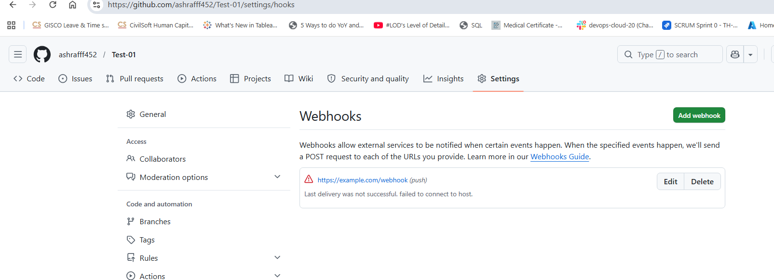

- Basic understanding of .git file.
The .git item in our project is actually a hidden
folder(directory), not a single file.
It is the brain of your git repo, containing every piece of
information Git needs to manage your project’s version
1.objects/ : heart of the database
2.refs/ : contains pointers to specific commits
3.index: also known as “staging area”, this file lists
what changes are ready to be included in you next commits
4.HEAD: a small file that points to the branch you are
currently working on.
5.config: contains project specific settings, such as
remote repo urls and your user preference
6.hooks/ : a folder for scripts that git can run
automatically before or after certain events
Why shouldn’t touch it:
1.stability: deleting or incorrectly editing files here
can corrupt your entire repo
2.hidden status: by default, it is hidden so you don’t
accidentally delete it while managing your project’s source
code.
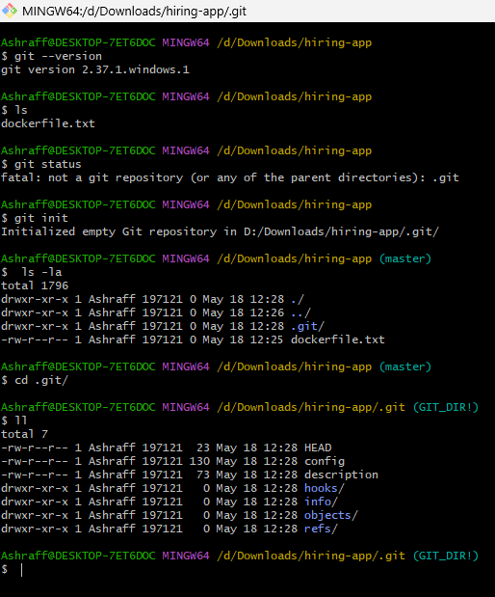

- Check all the logs of git.
Git log command is used to check the logs
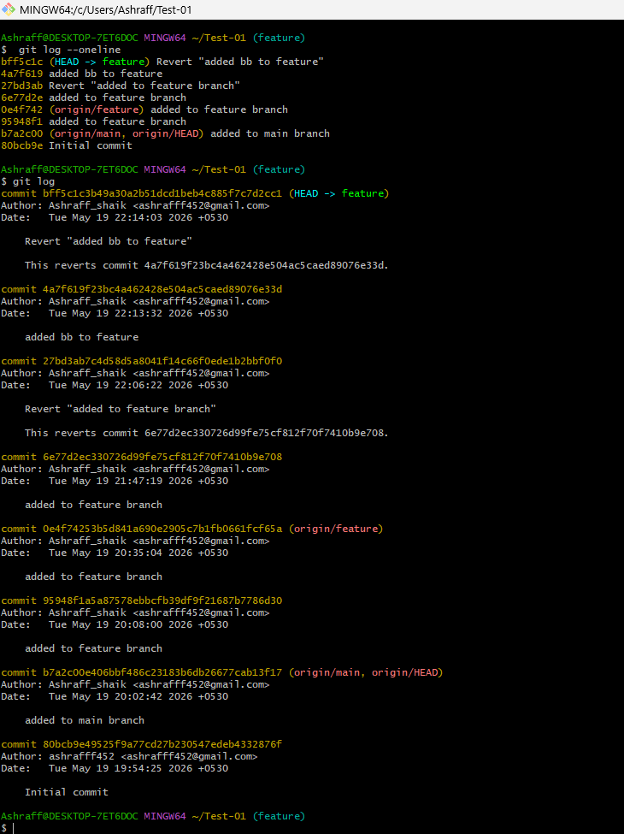

- Rename the commit message.
We use the command to rename the commit
git commit --amend -m “changes added”
Amend will only change the last commit message
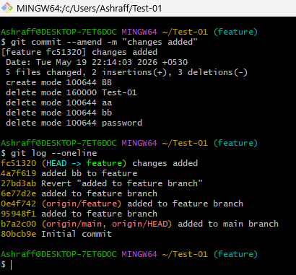

- Merge multiple commits into single commit.
We use git rebase -I HEAD~3 command
